Partial / residual correlation: GBPUSD and EURGBP
Method 07 / daily log returns / leave-currency-out USD factor / Alpari D1 full available history

Study setup
Logical pair: GBPUSD , EURGBP
Broker symbols: GBPUSD_i , EURGBP_i
Snapshot: 2026-11-03_majors_alpari_D1
Timeframe: D1
Matched return window: 1999-01-06 to 2026-11-02 (UTC bar dates)
Matched return count n: 7129
Dropped unfinished last bar dated 2026-11-03 UTC after a tick-volume check against the prior complete day.
USD-strength sign rule: minus log return when USD is the quote (EURUSD, GBPUSD, AUDUSD, NZDUSD); plus log return when USD is the base (USDJPY, USDCHF, USDCAD). EURGBP is never a constituent.
Control z constituents (5): AUDUSD, NZDUSD, USDJPY, USDCHF, USDCAD
z_t = equal-weight mean of those USD-strength returns on the same day
Complete matched rows (Excel): GBPUSD-EURGBP_Partial_D1.xlsx
Complete matched rows (HTML table): GBPUSD-EURGBP_Partial_D1_data.html

Method carried forward
Partial / residual correlation regresses each matched daily log return of close, ln(close_t / close_t-1), on the same leave-currency-out USD strength factor z, then takes Pearson correlation of the two residual series. Quotes are not inverted. z is the equal-weight mean of USD-strength returns from other majors that do not share a non-USD currency with either leg; EURGBP is never a constituent. USD-strength is minus the log return when USD is the quote (EURUSD, GBPUSD, AUDUSD, NZDUSD) and plus the log return when USD is the base (USDJPY, USDCHF, USDCAD). OLS uses an intercept on each leg. rho_partial is symmetric under swap of the two symbols. It describes leftover linear co-movement after removing linear z; it is not a cause, not a lead, and not a trading signal. Daily rows are not independent and residuals are estimated, so the two-sided p-value and Fisher interval are secondary. Same-sample raw Pearson r is a side check only.

Regression on z
leg | intercept_a_or_c | slope_b_or_d | R2
GBPUSD | -3.767e-05 | -0.73905742 | 0.39075584
EURGBP | 2.164e-05 | -0.15267618 | 0.02239474

Results
rho_partial: -0.637625
Two-sided p-value: 0
Approximate 95% Fisher interval: [-0.651200, -0.623643]
Same-sample raw Pearson r: -0.398542
rho_partial minus r: -0.239083

Conclusion
Over 7129 matched daily rows for GBPUSD and EURGBP after removing a leave-currency-out USD factor built from 5 constituents, rho_partial is -0.6376 (negative, moderate residual linear link in this sample). Approximate 95% Fisher interval: [-0.6512, -0.6236]. Same-sample raw Pearson r is -0.3985 (partial minus r = -0.2391). Leg R-squared on z: GBPUSD=0.3908, EURGBP=0.0224. Two-sided p under the usual independent-pairs model is 0; residuals are estimated and daily FX rows are linked, so treat p as secondary. This does not establish cause, lead-lag, or a lasting trading rule.

Charts
Daily closes
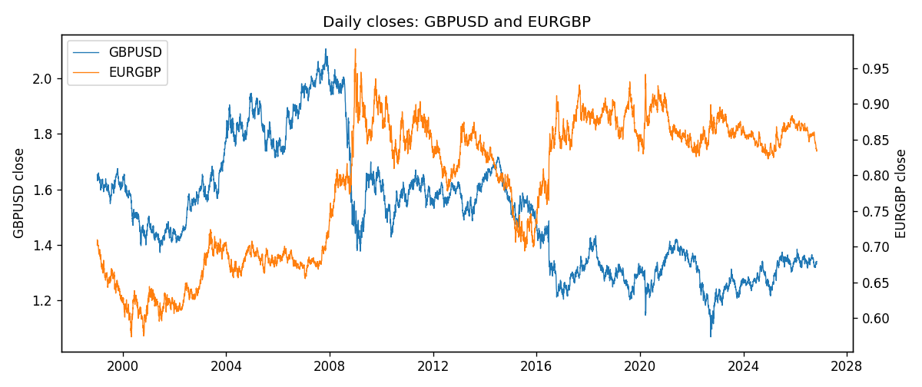
Log returns and control z
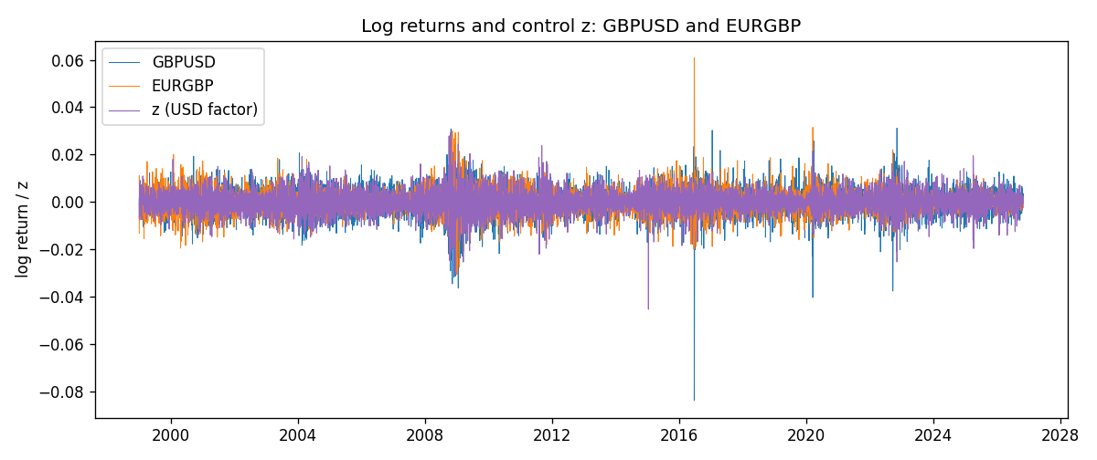
Residual scatter e_x vs e_y
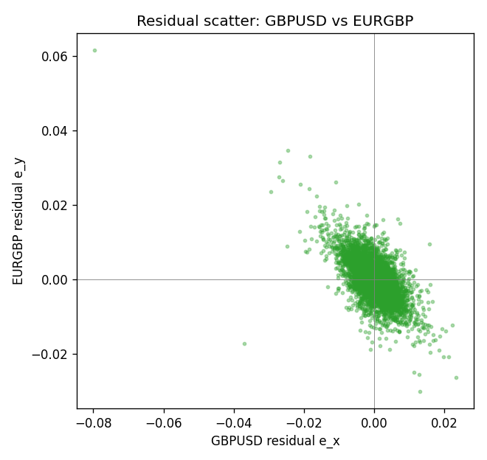

Data report
Every matched row that entered the partial correlation is stored in the sibling Excel workbook named GBPUSD-EURGBP_Partial_D1.xlsx. That file is the complete data archive for redrawing charts. Embedding all rows as a Word table is impractical at this length; the Word file holds the column list, column summaries, and the first and last 15 matched rows.
Columns: time, GBPUSD_open, EURGBP_open, GBPUSD_high, EURGBP_high, GBPUSD_low, EURGBP_low, GBPUSD_close, EURGBP_close, GBPUSD_tick_volume, EURGBP_tick_volume, GBPUSD_spread, EURGBP_spread, GBPUSD_real_volume, EURGBP_real_volume, GBPUSD_log_return, EURGBP_log_return, usd_strength_AUDUSD, usd_strength_NZDUSD, usd_strength_USDJPY, usd_strength_USDCHF, usd_strength_USDCAD, z, GBPUSD_fitted, EURGBP_fitted, GBPUSD_resid, EURGBP_resid
Column summaries (matched calculation rows)
column | count | mean | std | min | 25% | 50% | 75% | max
GBPUSD_open | 7129 | 1.5144316 | 0.21807268 | 1.06854 | 1.32366 | 1.50948 | 1.6297 | 2.1066
EURGBP_open | 7129 | 0.78787915 | 0.09637748 | 0.5734 | 0.6884 | 0.83444 | 0.8655 | 0.9769
GBPUSD_high | 7129 | 1.5207265 | 0.21864101 | 1.08366 | 1.32885 | 1.51609 | 1.63708 | 2.1161
EURGBP_high | 7129 | 0.79096121 | 0.09675282 | 0.5789 | 0.6905 | 0.83739 | 0.86841 | 0.9799
GBPUSD_low | 7129 | 1.5081146 | 0.21729988 | 1.03518 | 1.31854 | 1.50113 | 1.62306 | 2.0983
EURGBP_low | 7129 | 0.78517685 | 0.09619509 | 0.5682 | 0.6863 | 0.83221 | 0.86303 | 0.9661
GBPUSD_close | 7129 | 1.5144974 | 0.21803242 | 1.06879 | 1.32374 | 1.50955 | 1.62967 | 2.1065
EURGBP_close | 7129 | 0.78792406 | 0.09637588 | 0.5735 | 0.6884 | 0.83444 | 0.86555 | 0.977
GBPUSD_tick_volume | 7129 | 95701.191 | 154072.23 | 62 | 10128 | 53558 | 92161 | 1273370
EURGBP_tick_volume | 7129 | 87747.814 | 145877.32 | 332 | 6718 | 44856 | 82002 | 1424684
GBPUSD_spread | 7129 | 26.790433 | 19.183483 | 0 | 10 | 20 | 50 | 50
EURGBP_spread | 7129 | 21.135222 | 19.050893 | 0 | 4 | 13 | 40 | 50
GBPUSD_real_volume | 7129 | 3.5920049e+09 | 8.4862838e+10 | 0 | 0 | 0 | 0 | 2.4038164e+12
EURGBP_real_volume | 7129 | 2.8078235e+10 | 1.3570431e+11 | 0 | 0 | 0 | 0 | 3.5726265e+12
GBPUSD_log_return | 7129 | -2.43e-05 | 0.00564721 | -0.08388241 | -0.00312535 | 3.215e-05 | 0.00318107 | 0.03112653
EURGBP_log_return | 7129 | 2.44e-05 | 0.00487311 | -0.03067367 | -0.00262262 | -9.978e-05 | 0.00256826 | 0.06075387
usd_strength_AUDUSD | 7129 | -3.429e-05 | 0.00755471 | -0.0806166 | -0.004155 | -0.00029309 | 0.00384986 | 0.08602525
usd_strength_NZDUSD | 7129 | -2.603e-05 | 0.00764647 | -0.05966839 | -0.0045915 | -0.00024088 | 0.00423176 | 0.07027433
usd_strength_USDJPY | 7129 | 5.124e-05 | 0.0062132 | -0.03908203 | -0.00320044 | 0.00012446 | 0.00340927 | 0.05184024
usd_strength_USDCHF | 7129 | -7.228e-05 | 0.00659123 | -0.19545699 | -0.00334859 | 7.816e-05 | 0.00331593 | 0.09051364
usd_strength_USDCAD | 7129 | -9.1e-06 | 0.00514798 | -0.03859748 | -0.00283484 | 5.567e-05 | 0.00272835 | 0.03436319
z | 7129 | -1.809e-05 | 0.00477648 | -0.04542184 | -0.00270496 | -6.63e-06 | 0.00273674 | 0.0291122
GBPUSD_fitted | 7129 | -2.43e-05 | 0.00353009 | -0.02155326 | -0.00206028 | -3.277e-05 | 0.00196145 | 0.03353167
EURGBP_fitted | 7129 | 2.44e-05 | 0.00072926 | -0.0044231 | -0.00039619 | 2.265e-05 | 0.00043462 | 0.00695647
GBPUSD_resid | 7129 | 0 | 0.00440788 | -0.07958609 | -0.00224361 | 7.999e-05 | 0.00241169 | 0.02325594
EURGBP_resid | 7129 | -0 | 0.00481824 | -0.03003515 | -0.00266351 | -0.00014872 | 0.00253646 | 0.06161199
First 15 matched rows (selected columns)
time | GBPUSD_close | EURGBP_close | GBPUSD_log_return | EURGBP_log_return | z | GBPUSD_fitted | EURGBP_fitted | GBPUSD_resid | EURGBP_resid
1999-01-06 | 1.6537 | 0.7019 | -0.00060452184 | -0.013303338 | 0.0013918159 | -0.0010663037 | -0.00019085698 | 0.00046178188 | -0.013112481
1999-01-07 | 1.6502 | 0.7097 | -0.002118709 | 0.011051402 | -0.00717622 | 0.0052659668 | 0.001117278 | -0.0073846758 | 0.0099341238
1999-01-08 | 1.6405 | 0.7062 | -0.0058954193 | -0.004943862 | 0.00089151303 | -0.00069655117 | -0.00011447265 | -0.0051988681 | -0.0048293894
1999-01-11 | 1.6312 | 0.7053 | -0.0056851331 | -0.0012752393 | -0.0063849374 | 0.0046811635 | 0.00099646802 | -0.010366297 | -0.0022717073
1999-01-12 | 1.6349 | 0.7077 | 0.0022657001 | 0.0033970309 | 0.0078557747 | -0.0058435404 | -0.0011777495 | 0.0081092405 | 0.0045747804
1999-01-13 | 1.6499 | 0.708 | 0.0091330396 | 0.00042381861 | 0.0024568143 | -0.0018533987 | -0.00035345687 | 0.010986438 | 0.00077727548
1999-01-14 | 1.6531 | 0.7066 | 0.0019376331 | -0.0019793588 | 0.0014789102 | -0.0011306714 | -0.0002041542 | 0.0030683044 | -0.0017752046
1999-01-15 | 1.6502 | 0.7012 | -0.0017558204 | -0.0076715819 | 0.0022811788 | -0.001723594 | -0.00032664151 | -3.2226414e-05 | -0.0073449404
1999-01-18 | 1.6522 | 0.7017 | 0.0012112405 | 0.00071280921 | -0.00024014877 | 0.00013981187 | 5.8305153e-05 | 0.0010714286 | 0.00065450406
1999-01-19 | 1.6553 | 0.7007 | 0.0018745281 | -0.0014261269 | -0.0024056471 | 0.0017402394 | 0.00038892516 | 0.0001342887 | -0.001815052
1999-01-20 | 1.6472 | 0.7021 | -0.0049053846 | 0.0019960086 | -0.0018913686 | 0.0013601581 | 0.00031040708 | -0.0062655427 | 0.0016856016
1999-01-21 | 1.6524 | 0.7016 | 0.0031518998 | -0.00071240297 | -0.0008965964 | 0.00062496436 | 0.00015852907 | 0.0025269354 | -0.00087093204
1999-01-22 | 1.6565 | 0.7004 | 0.0024781662 | -0.0017118406 | 0.0065413802 | -0.0048721274 | -0.0009770728 | 0.0073502937 | -0.00073476784
1999-01-25 | 1.6585 | 0.6966 | 0.0012066366 | -0.0054402425 | 0.00069212726 | -0.00054919364 | -8.403119e-05 | 0.0017558303 | -0.0053562113
1999-01-26 | 1.6597 | 0.6962 | 0.00072328374 | -0.00057438255 | -0.00084667112 | 0.00058806671 | 0.00015090667 | 0.00013521703 | -0.00072528922
Last 15 matched rows (selected columns)
time | GBPUSD_close | EURGBP_close | GBPUSD_log_return | EURGBP_log_return | z | GBPUSD_fitted | EURGBP_fitted | GBPUSD_resid | EURGBP_resid
2026-10-13 | 1.32534 | 0.84458 | 0.0036434319 | 0.00020130374 | -0.0034523595 | 0.0025138201 | 0.00054873323 | 0.0011296118 | -0.00034742949
2026-10-14 | 1.31884 | 0.84553 | -0.0049164679 | 0.0011241873 | 0.0019566155 | -0.001483723 | -0.00027708842 | -0.0034327449 | 0.0014012757
2026-10-15 | 1.32757 | 0.84479 | 0.0065976411 | -0.00087557391 | -0.0024933787 | 0.0018050782 | 0.0004023197 | 0.0047925629 | -0.0012778936
2026-10-16 | 1.33257 | 0.84307 | 0.0037592051 | -0.0020380844 | -0.0033151583 | 0.0024124205 | 0.00052778587 | 0.0013467846 | -0.0025658703
2026-10-19 | 1.33024 | 0.84259 | -0.0017500314 | -0.00056950988 | -0.00034627659 | 0.00021824642 | 7.4508344e-05 | -0.0019682779 | -0.00064401822
2026-10-20 | 1.3377 | 0.83957 | 0.0055923442 | -0.0035906254 | -0.0031542728 | 0.0022935169 | 0.00050322249 | 0.0032988274 | -0.0040938479
2026-10-21 | 1.33937 | 0.83839 | 0.0012476328 | -0.00140647 | -0.0016549997 | 0.001185468 | 0.00027431919 | 6.2164875e-05 | -0.0016807892
2026-10-22 | 1.33967 | 0.83682 | 0.00022396082 | -0.0018743924 | -0.0022915707 | 0.0016559304 | 0.00037150841 | -0.0014319696 | -0.0022459008
2026-10-23 | 1.33684 | 0.83751 | -0.0021146949 | 0.00082421033 | 0.00011246441 | -0.00012078952 | 4.4695191e-06 | -0.0019939054 | 0.00081974081
2026-10-26 | 1.33359 | 0.83762 | -0.0024340661 | 0.00013133309 | 0.0024248906 | -0.0018298053 | -0.00034858289 | -0.00060426086 | 0.00047991598
2026-10-27 | 1.33044 | 0.83595 | -0.0023648393 | -0.0019957343 | 0.001302035 | -0.00099995048 | -0.00017714958 | -0.0013648889 | -0.0018185848
2026-10-28 | 1.33254 | 0.83651 | 0.0015771808 | 0.00066967224 | -3.441931e-05 | -1.2234009e-05 | 2.6895165e-05 | 0.0015894148 | 0.00064277708
2026-10-29 | 1.33733 | 0.83553 | 0.0035881935 | -0.0011722209 | -0.00037863446 | 0.00024216075 | 7.9448619e-05 | 0.0033460328 | -0.0012516695
2026-10-30 | 1.33913 | 0.83351 | 0.0013450605 | -0.0024205543 | -0.00051583808 | 0.00034356211 | 0.00010039635 | 0.0010014984 | -0.0025209507
2026-11-02 | 1.3406 | 0.83426 | 0.0010971256 | 0.00089940465 | 0.0007255725 | -0.00057391159 | -8.9137483e-05 | 0.0016710372 | 0.00098854214

